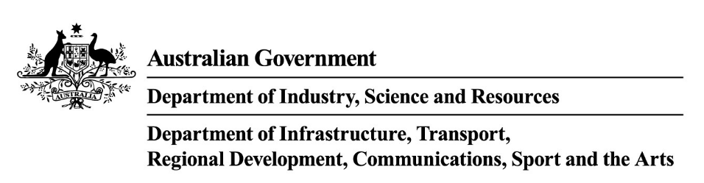
Stronger Communities Programme Round 9
Factsheet: Hinkler & Maribyrnong

The Stronger Communities Programme supports the Australian Government’s commitment to deliver social benefits in communities across Australia by funding projects in each of the Federal Electorates. The program provides grants for community projects to strengthen and benefit local communities and is part of the Government’s 2024-25 Budget initiatives. All projects must be completed by 30 April 2026.

What does it offer?
For Round 9 of the program, $22.65 million is available to provide up to $150,000 to each federal electorate for eligible community projects that encourage and support participation in local projects, improve local community participation and contribute to vibrant and viable communities.
A maximum of 20 projects will be funded in each federal electorate.
Round 9 of the program aims to support projects that provide social benefits for local communities. For this round, grant funding will be up to 100 per cent of eligible project costs except for local governing bodies where grant funding will be up to 50 per cent of eligible project costs. Local governing bodies must provide matched funding contributions towards their eligible project.
- The minimum grant amount is $2,500
- The maximum grant amount is $20,000.
- The maximum cost of your project cannot exceed $50,000.

How does it work?
Local Federal Members of Parliament (MP) may choose to participate in the program. If they do, they must consult with either an existing consultation committee or establish a new consultation committee with representatives from the local community.
The MP and the consultation committee identify potential applicants and projects in their electorate. The identified projects must be consistent with the intended outcomes of the program and eligibility criteria.
The MP will invite potential applicants to apply for a grant to deliver specific eligible projects. The invitation will provide details on how to apply via the online grant portal. Your MP must advise the Department of Industry, Science and Resources (DISR) of the basis for project selection.
To be eligible you must be invited by your MP to apply, and your project must:
- include at least one of the specific eligible activities that directly aligns with one or more of the program objectives deliver social benefits to your community
- include eligible activities and eligible expenditure
- be located at an address in your MP’s electorate (Federal electorate boundaries are as at the 2022 Federal election. Use the digital.atlas.gov.au with reference to the Glossary for more information on determining project location eligibility in electorates)
- be held within your MP’s electorate in the case of events or used in your MP’s electorate if it includes portable equipment
- have at least $2,500 in eligible
expenditure, unless the applicant is a local
governing body which requires at least $5,000 in eligible expenditure. For Round 9, in-kind contributions are not considered eligible expenditure.
- have a maximum project cost of $50,000
- You must complete your project no later than 30 April 2026

The project and grant amount in your application must be the same as that agreed to and nominated by your MP.

Who can apply?
To be eligible you must
- be invited to apply by your MP
- have an Australian Business Number (ABN)
and be one of the following entities:
- an incorporated not-for-profit entity (the grant opportunity guidelines provide detail on how you must demonstrate your ‘not-for-profit’ status)
- a local governing body as defined by the Local Government (Financial Assistance) Act 1995
- a Commonwealth, state or territory government agency or entity that is a fire service, rural fire service, country fire
authority, state emergency service or similar.
- an incorporated trustee on behalf of a trust with responsibility for a community asset or
property. You will be required to provide relevant trust documents.
For further information on program eligibility refer to the grant opportunity guidelines.

Who is not eligible to apply?
You are not eligible to apply if you are:
- a for profit organisation
- an individual
- a partnership
- a Regional Development Australia Committee
- a university, technical college or school
- a hospital
- a Commonwealth, State or Territory government agency or body (including government business enterprises) unless listed in section 4.1 of the grant opportunity guidelines.
- an organisation, or your project partner is an organisation, included on the National Redress Scheme’s website on the list of ‘Institutions that have not joined or signified their intent to join the Scheme’ (www.nationalredress.gov.au)
- an employer of 100 or more employees that has not complied with the Workplace Gender Equality Act (2012).

Can I apply if my organisation is not an incorporated entity?
If your organisation is not an incorporated entity, you are not eligible to apply. However, you may be able to nominate an eligible project sponsor to apply on your behalf provided they agree to sponsor your organisation and they also meet the program’s eligibility criteria.
The project sponsor can apply on your behalf and must:
- be invited to apply by your MP
- meet the program’s eligibility criteria
- submit the Stronger Communities Programme online application
- if successful, enter into a grant agreement with the Commonwealth
- ensure that the grant is spent on the project and in accordance with the agreement.

I received funding under a previous round of the Stronger Communities Programme. Can I apply for Round 9?

Yes, however you must be invited by your MP to apply. You can contact your local MP to express your interest in the program.

Round 9 is different to previous rounds
Important changes have been made to the grant opportunity guidelines from previous rounds of the program. This includes updates to eligible activities and program objectives.
To be eligible, projects must directly align and give effect to at least one of the objectives of the program and must be one or more of the specific activities listed in the grant opportunity guidelines.
Please ensure you read the guidelines thoroughly before applying.

What activities are eligible?
Eligible activities are listed in section 5.1 of the grant opportunity guidelines. They must directly relate to at least one of the project objectives listed in section 2 of the guidelines. Some examples of eligible project activities are:

- Installation of public art that celebrates Indigenous heritage.
- Installation of a new war memorial that commemorates Australians killed or injured in war.
- Implementing energy-efficient lighting in public spaces to reduce carbon footprint.
- Installation of solar panels at a local community centre.
- Constructing a disability access ramp or lift at a local sporting facility.
- Upgrading facilities at a community theatre to support local performing arts.
- Installation of a native garden to educate the community and celebrate Indigenous Australians and their culture.
- Construction of a women’s change room at a local football ground.
- Establishing a community garden to promote sustainable living and provide educational opportunities.
Please ensure you read the guidelines thoroughly before applying.

How will my application be assessed?
It is important to note that being invited to submit an application by your MP does not guarantee that your application will be successful.
DISR will assess your application for completeness and against all the eligibility criteria and alignment with program objectives. If eligible, your application will be assessed against the assessment criterion.
To be recommended for funding, your project must meet all eligibility and assessment criteria, provide value with relevant money and be considered a proper use of public resources.
The Program Delegate decides which grants to approve taking into account the eligibility assessment by the department, any reputational risk to the Australian Government, information you provide, and the availability of grant funds.

When can I start my project?
You may start your project from the date you submit your application online.
If you choose to start your project before you enter into a grant agreement with the Commonwealth, any costs incurred are at your own risk. You must incur the project expenditure between the project start and end date for it to be eligible. You will not receive any funding if your application is unsuccessful.

What will I need to do if successful?
You must enter into a grant agreement with the Commonwealth.
The grant agreement will state the:
- maximum grant amount we will pay
- proportion of eligible expenditure covered by the grant (grant percentage).
We will pay 100 per cent of the grant on execution of the grant agreement. You will be required to report how you spent the grant funds at the completion of the project.

How do I apply?
You should read the grant opportunity guidelines before you apply.
To apply you must
- be invited by your MP to submit an application for your project
- complete the online Stronger Communities Programme application form accessed by the link in the email you receive from your MP
- provide all the information requested
- address all eligibility criteria
- include all requested attachments.

Where can I find more information?

For more information, visit business.gov.au or call 13 28 46

