Prime Minister’s Prize for Science Teaching: Stage 2 nominator submissions
The 2026 Prime Minister’s Prize for Science Teaching is requesting the submission of a video file for Stage 2 nominations.
All successful Stage 1 nominators were emailed with a link to the consultation hub used for the submission of audio and/or video material. This is a private link, and we ask you not to share it.
If you are a successful Stage 1 nominator for the Prime Minister’s Prize for Science Teaching and have not received your email, please contact the Department at PM Prizes Administration pmprizes.admin@industry.gov.au as soon as possible.
You are to provide a video showcasing the nominee in their teaching environment (up to 3 minutes in length) in support of Assessment Criterion 2.
You can submit referee reports until 5PM AEST 23 April 2026. We will not accept late submissions.
Nominators are responsible for submitting their own and any supporter audio/video submission using the link provided in the email.

Start page
The page will give you details on what you can submit and where to find additional submission guidance.
To make a submission, click on ‘Make a submission’.
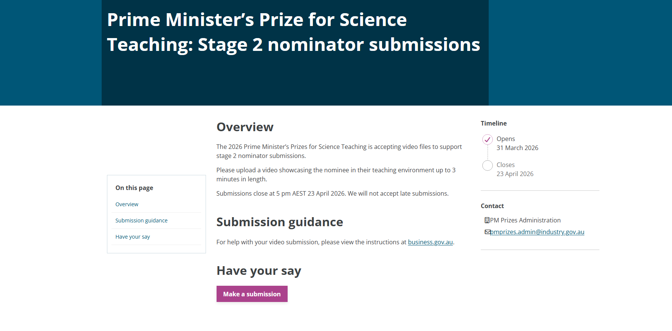

Privacy Collection Statement
If you agree with the Privacy Collection Statement, click ‘Yes, I agree’. This will enable the ‘Next>’ button at the bottom of page. If you do not agree, you will not be able to proceed.
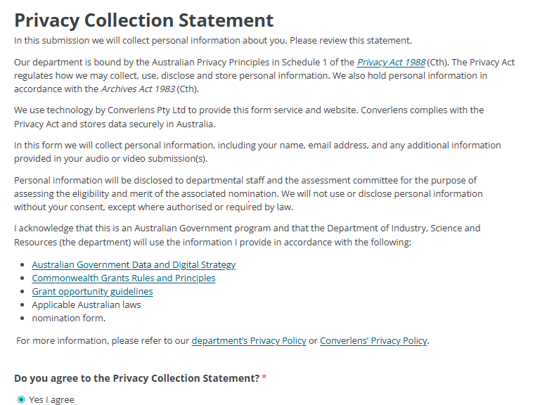

About the nominator
Please provide your details to allow us to identify which nomination you are submitting a referee report for.
Complete all sections marked with the * to proceed.
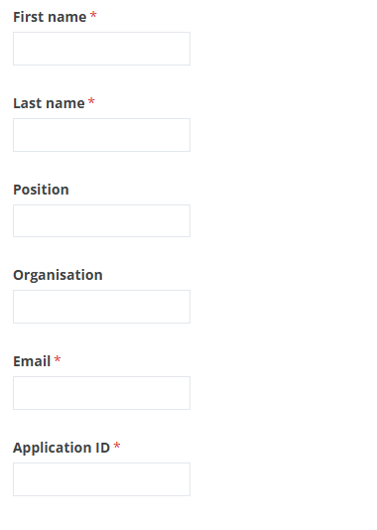

Declaration
I approve the information in this nomination being communicated to the department in electronic form.
I acknowledge that if the department believes that any statement in a nomination is incorrect, incomplete, false or misleading it may take appropriate action.
For example:
- excluding a nomination from further consideration
- withdrawing an offer of funding
- using the information in the nomination for a fraud investigation consistent with the Australian Government’s Investigations Standards and Commonwealth Fraud Control Framework
- for a grant under management, terminating a grant agreement between the Commonwealth and the grantee including recovering funds already paid.
[check box] I agree
Click ‘Next>’ to proceed.

Your submission
You can now upload your file.
Upload a video submission showcasing the nominee in their teaching environment. The video can be up to 3 minutes in length, and the file size needs to be under 1GB.
[Upload box]

Click ‘Click to choose a file’. This will open a pop-up window that allows you to select the file you would like to upload onto the system. You can only upload one video file with a size limit of 1 GB.
Click ‘Next>’ to proceed.

Almost done
You are now able to submit your file. Please ensure all your details are current and correct. Once you click ‘Submit’, you will no longer be able to go back and change anything.
We may contact you if we have any questions regarding the information supplied or if your submission is incomplete.
If you have issues with your submission, please contact our office on pmprizes.admin@industry.gov.au for assistance.

