Prime Minister’s Prize for Aboriginal and Torres Strait Islander Knowledge Systems: Stage 2 referee submissions

The 2026 Prime Minister’s Prize for Aboriginal and Torres Strait Islander Knowledge Systems is accepting audio and video files to support stage 2 referee reports.
The referee’s role is to review the statement of claims against the assessment criteria provided by the nominator and supporters.
We will contact the nominated referee and request the referee report by email. This email will contain the referee report template and the link to the consultation hub used for the submission of audio and/or video material. This is a private link, and we ask you not to share it.
You can provide your referee report either:
- as an audio or video submission up to 5 minutes in length. If the submission is in a language other than English, you must also submit a written transcript of the content in English, or
- as a written submission, emailed to Pmprizes.admin@industry.gov.au.
You can submit referee reports until 5PM AEST 18 May 2026.

Start page
The page will give you details on what you can submit and where to find additional submission guidance.
To make a submission, click on “Make a submission.”
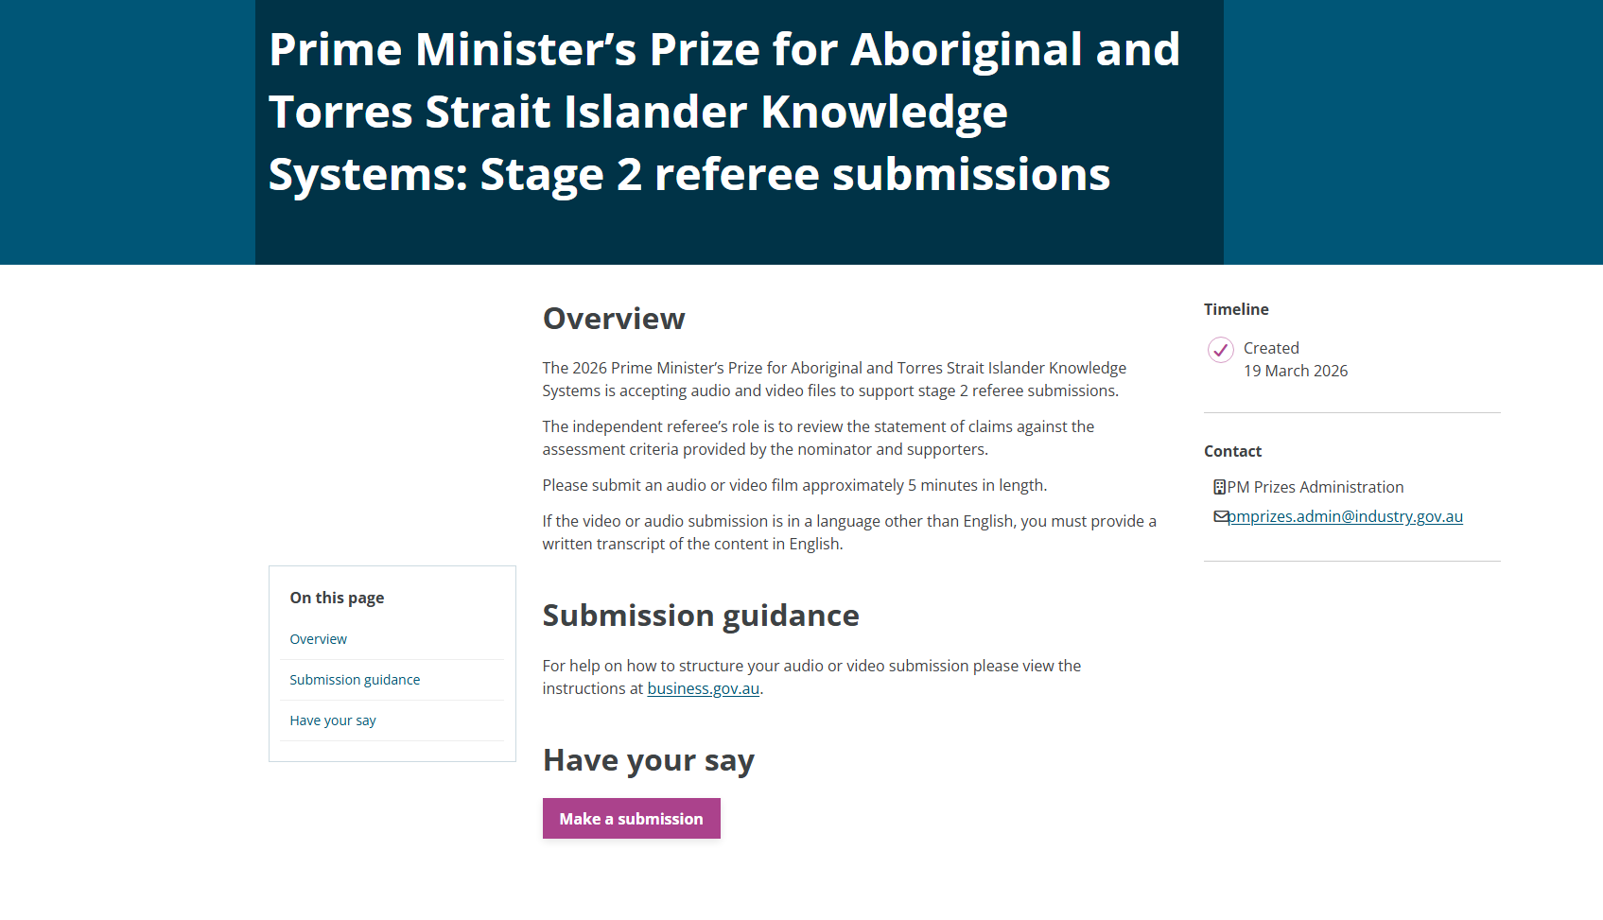

Privacy Collection Statement
If you agree with the Privacy Collection Statement, click ‘Yes, I agree’. This will enable the ‘Next>’ button at the bottom of page. If you do not agree, you will not be able to proceed.
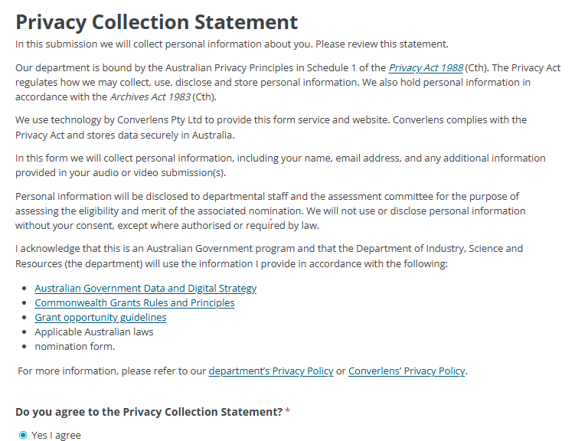

About you
Please provide your details to allow us to identify which nomination you are submitting a referee report for.
Complete all sections marked with the * to proceed.
Please fill in details of the nominator along with the application ID.
First name (required) *

Last name (required) *

Position (optional)

Organisation (optional) *

Email (required) *

Name of nominee (required) *

Application ID (optional) *

Click ‘Next>’ to proceed.
Your submission
You can now upload your file.

Independent Referee

Click ‘Click to choose a file’. This will open a pop-up window that allows you to select the file you would like to upload onto the system. You can only upload one audio/video file with a size limit of 1 GB.
If required, you can upload an English transcript of the file in the next box.
Provide a short description (300 characters) of your relevant expertise and a declaration of your independence from the nominee in the boxes provided.
Click ‘Next>’ to proceed.

Declaration
I approve the information in this nomination being communicated to the department in electronic form.
I acknowledge that if the department believes that any statement in a nomination is incorrect, incomplete, false or misleading it may take appropriate action.
For example:
- excluding a nomination from further consideration
- withdrawing an offer of funding
- using the information in the nomination for a fraud investigation consistent with the Australian Government’s Investigations Standards and Commonwealth Fraud Control Framework
- for a grant under management, terminating a grant agreement between the Commonwealth and the grantee including recovering funds already paid.
[check box] I agree
Next >

Almost done
You are now able to submit your file/s. Please ensure all your details are current and correct. Once you click ‘Submit’, you will no longer be able to go back and change anything.
We may contact you if we have any questions regarding the information supplied or if your submission is incomplete.
If you have issues with your submission, please contact our office on pmprizes.admin@industry.gov.au for assistance.

