Prime Minister’s Prize for Aboriginal and Torres Strait Islander Knowledge Systems: Stage 2 nominator/supporter submission
The 2026 Prime Minister’s Prize for Aboriginal and Torres Strait Islander Knowledge Systems is accepting audio and video files to support stage 2 nominator/ supporter submissions.
All successful Stage 1 nominators were emailed with a link to the consultation hub used for the submission of audio and/or video material. This is a private link, and we ask you not to share it.
If you are a successful Stage 1 nominator for the Prime Minister’s Prize for Aboriginal and Torres Strait Islander and have not received your email, please contact the Department at pmprizes.admin@industry.gov.au as soon as possible.
Submissions for audio and/or video material as part of the Stage 2 nominations will be open until 5pm AEST, 23 April 2026. We will not accept late submissions.
Nominators are responsible for submitting their own and any supporter audio/video submission using the link provided in the email.
Nominators can submit either:
- an audio or video submission up to 10 minutes in length (approximately 3 minutes and 20 seconds per criterion)
- a written submission as part of the stage 2 nomination form on the online Grants portal.
Nominators also have the option to submit a video of up to 5 minutes in length showcasing the knowledge system being practiced in the project.
If the submission is in a language other than English, you must also submit a written transcript of the content in English.
Supporters can submit either:
- an audio or video submission up to 7 minutes in length - approximately 2 minute 20 seconds per criterion
- a written submission as part of the stage 2 nomination form on the online Grants portal.
If the submission is in a language other than English, you must also submit a written transcript of the content in English.

Start page
The page will give you details on what you can submit and where to find additional submission guidance.
To make a submission, click on ‘Make a Submission’.
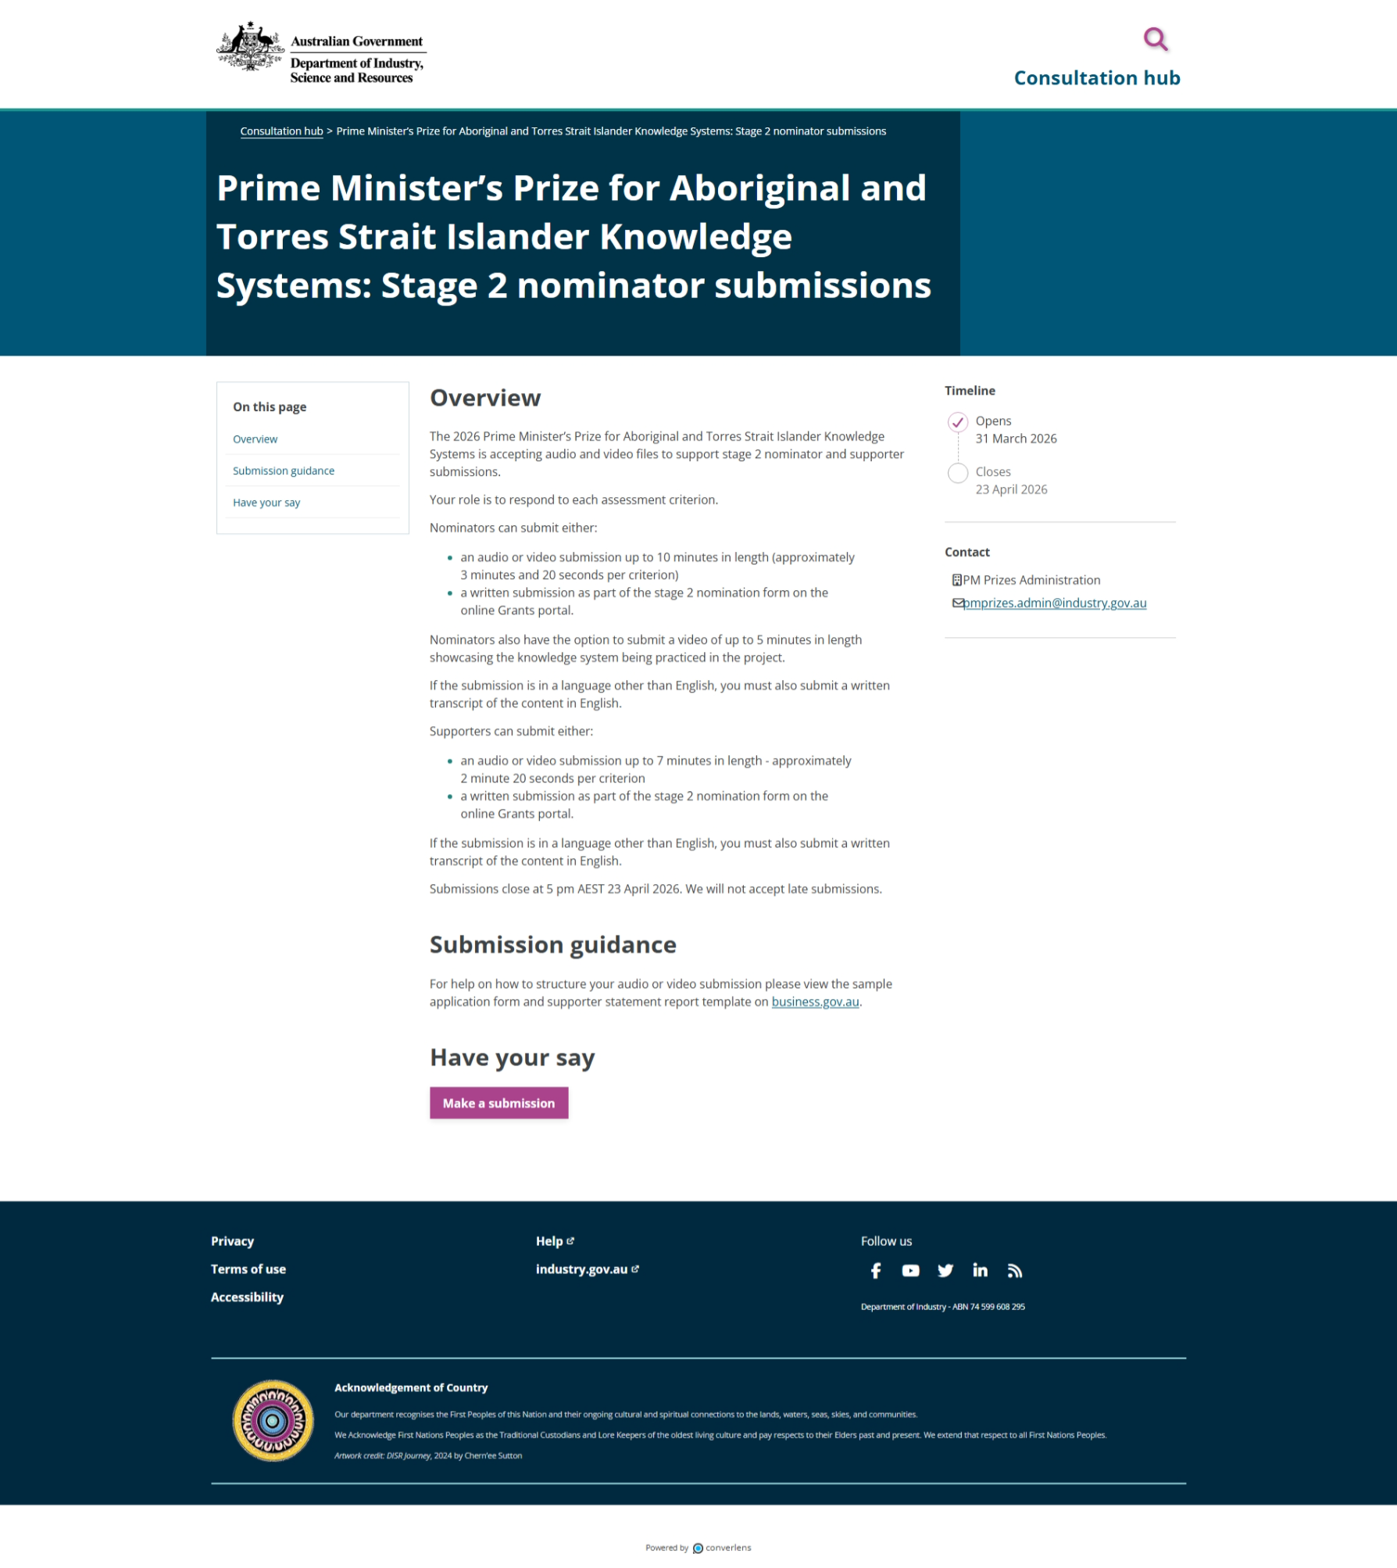

Privacy Collection Statement
If you agree with the Privacy Collection Statement, click ‘Yes, I agree’. This will enable the ‘Next>’ button at the bottom of page. If you do not agree, you will not be able to proceed.
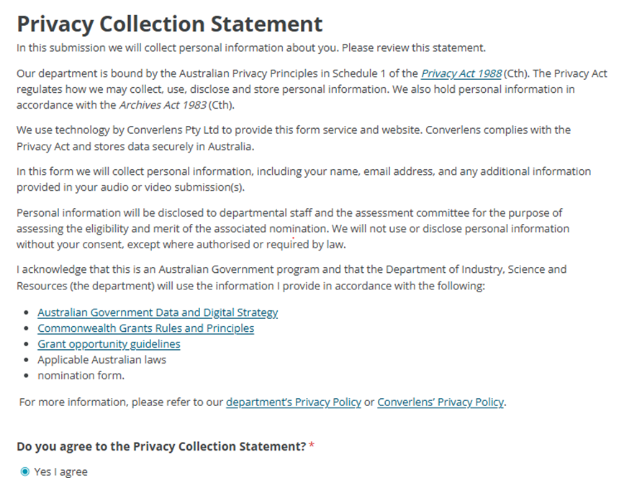

About you
Please provide your details to allow us to identify which nomination you are submitting a referee report for.
Complete all sections marked with the * to proceed.

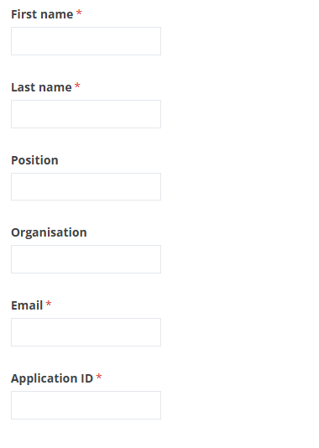

Click ‘Next>’ to proceed.

Your submission
You can now upload your files for the nominator and up to 2 supporters.

Nominator
Nominators can submit either:
- an audio or video submission up to 10 minutes in length (approximately 3 minutes and 20 seconds per criterion) or
- a written submission as part of the stage 2 nomination form on the online Grants portal.
Nominators also have the option to submit a video of up to 5 minutes in length showcasing the knowledge system being practiced in the project.
If the submission is in a language other than English, you must also submit a written transcript of the content in English.
When you click on ‘Click to choose a file’, it will open a pop-up window. This will allow you to select the file you would like to upload onto this system. You can only upload one file with a size limit of 1 GB.
Please fill in details of the nominator along with the application ID.
First name (required)

Last name (required)

Position (optional)

Organisation (optional)

Email (required)

Application ID (required)

Upload an audio or video submission from the nominator (10 minutes). Files need to be under 1GB.
[Upload box]
If required, you can upload an English transcript of the file in the next box.

Supporters
You can upload up to 2 supporter statements.
Supporter 1
Upload an audio or video submission from supporter 1 (7 minutes). Files need to be under 1GB.
[Upload box]
If the video or audio submission is in a language other than English, please upload an English transcript of this file.
[Upload box]
Description of my relationship with the nominee (300-character limit):

Description of my ability to offer informed opinions on the nomination (300-character limit):
Supporter 2
Upload an audio or video submission from supporter 2 (7 minutes). Files need to be under 1GB.
[Upload box]
If the video or audio submission is in a language other than English, please upload an English transcript of this file.
[Upload box]
Description of my relationship with the nominee (300-character limit):
Description of my ability to offer informed opinions on the nomination (300-character limit):
Next >
Supporters can submit either:
an audio or video submission up to 7 minutes in length - approximately 2 minute 20 seconds per criterion
a written submission as part of the stage 2 nomination form on the online Grants portal.
If the submission is in a language other than English, you must also submit a written transcript of the content in English.
When you click on ‘Click to choose a file’, it will open a pop-up window. This will allow you to select the file you would like to upload onto this system. You can only upload one file with a size limit of 1 GB.
Upload an English transcript of the file in the next box, if required.
For each supporter provide a short description (300 characters each) of the relationship with the nominee and the supporter’s ability to comment on the nomination in the boxes provided.
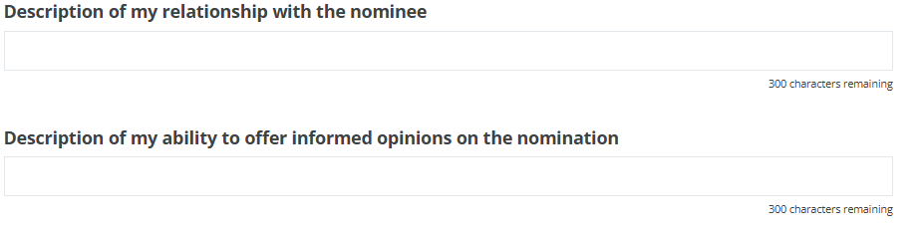
Click ‘Next>’ to proceed.
Declaration
I approve the information in this nomination being communicated to the department in electronic form.
I acknowledge that if the department believes that any statement in a nomination is incorrect, incomplete, false or misleading it may take appropriate action.
For example:
- excluding a nomination from further consideration
- withdrawing an offer of funding
- using the information in the nomination for a fraud investigation consistent with the Australian Government’s Investigations Standards and Commonwealth Fraud Control Framework
- for a grant under management, terminating a grant agreement between the Commonwealth and the grantee including recovering funds already paid.
[check box] I agree
Next >

Declaration
I approve the information in this nomination being communicated to the department in electronic form.
I acknowledge that if the department believes that any statement in a nomination is incorrect, incomplete, false or misleading it may take appropriate action.
For example:
- excluding a nomination from further consideration
- withdrawing an offer of funding
- using the information in the nomination for a fraud investigation consistent with the Australian Government’s Investigations Standards and Commonwealth Fraud Control Framework
- for a grant under management, terminating a grant agreement between the Commonwealth and the grantee including recovering funds already paid.
[check box] I agree
Next >

Almost done
You are now able to submit your files. Please ensure all your details are current and correct. Once you click ‘Submit’, you will no longer be able to go back and change anything.
We may contact you if we have any questions regarding the information supplied or if your submission is incomplete.
If you have issues with your submission, please contact our office on pmprizes.admin@industry.gov.au for assistance.

